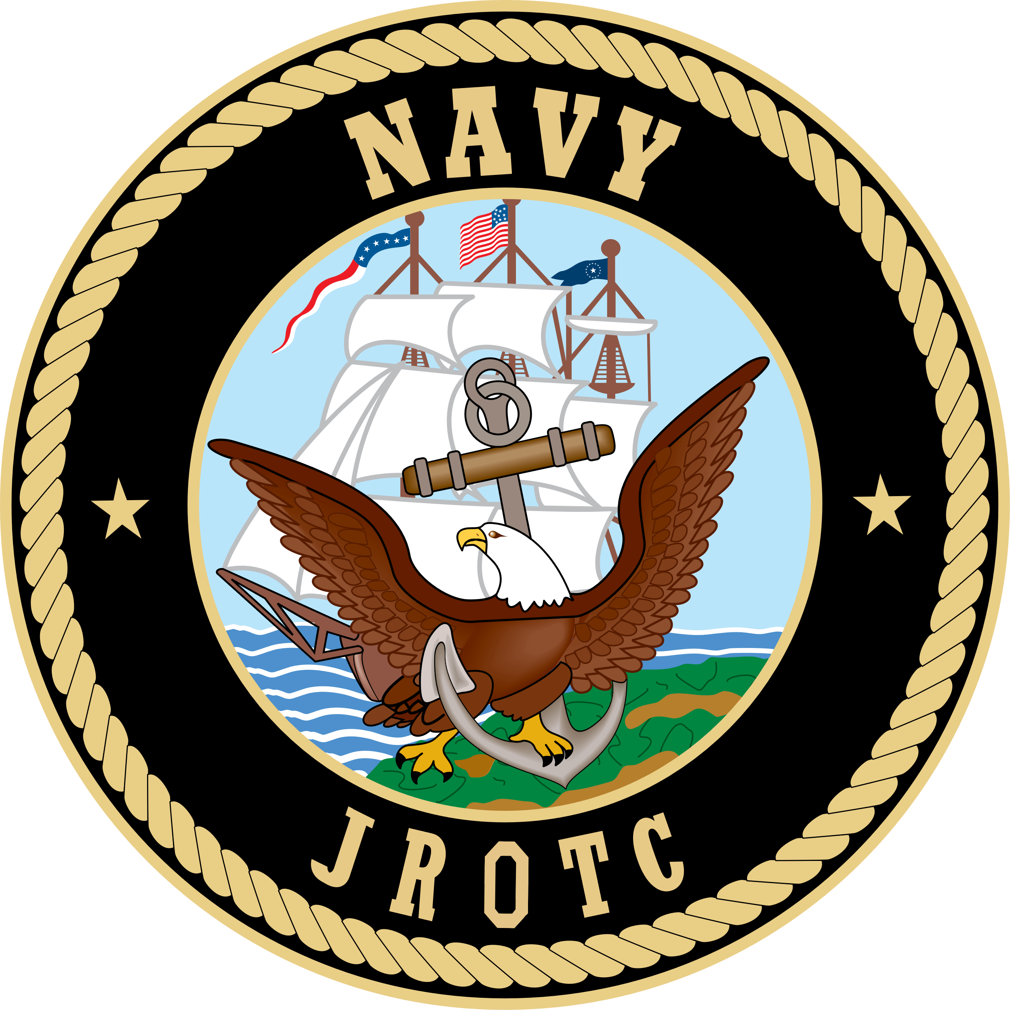

Meeting Minutes
Parents Association Meeting
Tuesday, December 14, 2021

In Attendance: Oscar Guttormsen, Deborah Guttormsen, Cari Gavin, Senior Chief Justin Beck
Meeting Called to Order at 1803
Minutes unavailable to review from last meeting
Have reached out to VP McGuffey regarding changing meetings to every 3rd Tuesday as he has conflict with 2nd Tuesday. Waiting for confirmation
Financial Report
- Letter writing campaign has brought in $4200 to date with more trickling in everyday
- Have total $19,480 this year compared with $16400 last year
- We are maintaining a handle on expenses
- See attached financial report
Old Business
- Ice Skating
  - Party was last week
  - There are volunteer opportunites with link in Google Classroom to sign up
- Swains
  - PT team went down to help 1 day with Christmas trees but then Swain’s hired someone else to do it (?person in need)
- Wreaths Across America
  - Ceremony is Saturday, December 18, 2021 at Sequim View Cemetary at 1100
  - Color Guard will be present
  - Cari will sent email blast with link to parents for last push
  - Wreaths are $15 with $5 of that coming to us
- Snohomish Comp Recap
  - All teams placed with exception of PT team
  - Had lots of food. Will need to coordinate better so not so much
  - Gavins donated lunch

New business
- Air Rifle Teams
  - Precision
    - Jenna Sanders place 1st in the Nation and Maggard placed 14th. Will be heading to Nationals in the New Year
- Sporter Team
  - Will be heading to Reno on January 8 for comp
- Both trips will be payed for by the Navy
- Home Comp Feb 26, 2022
  - Will need scoring parents as parents who used to score have left
    - will need new parents to go to future comps to see how scoring is done
    - Deb and Cari have volunteered
    - Sign Up Genius was sent out. Oscar will send out personal emails in the New Year to encourage parents to sign up. May have to make calls. Only have 67 cadets and there is a concern we won’t have enough volunteers. Cadets can fill in some areas but again there are only 67
- Future Comps
  - January 22, 2022 in Everett
  - February 12, 2022 in Oak Harbor
  - Will see about sending out Sign Up Genius to organize food
- Navy Ball
  - Set for May 14, 2022
  - Vern Burton reserved
  - Need to look into catering options
  - Oscar to get in touch with Jeff Cameron to see if willing to do again
  - Cari to reach out to other contacts
- Probation Status for Unit
  - Will receive 1st letter this month
  - Will receive 2nd letter sometime in March to ask school if we can reach the numbers we need
  - Captain has been reaching out the Mrs Lunt, principal of the Middle School without much success
    - Deb writing email to her
    - Used to do Color Guard at assemblies, Armed Drill team would go during their lunch and perform, let kids ask questions, touch/spin rifles, etc
    - ?Head of CTE Joslyn to reach out as well
    - Luke Gavin, CO, and School Board Student Rep will bring up at next School Board meeting
    - Brainstorming ideas of how to get the word out that NJROTC is fun
  - Program will continue next school year but if numbers aren’t reached will receive letter in October and program will be closed at end of school year 2023

Next meeting set for Tuesday, January 11, 2022 at 1800
Meeting adjourned at 1847

